### Copy/Monitoring Best Practices

* Do not change the name of the linked Revit files when using copy/monitoring
* 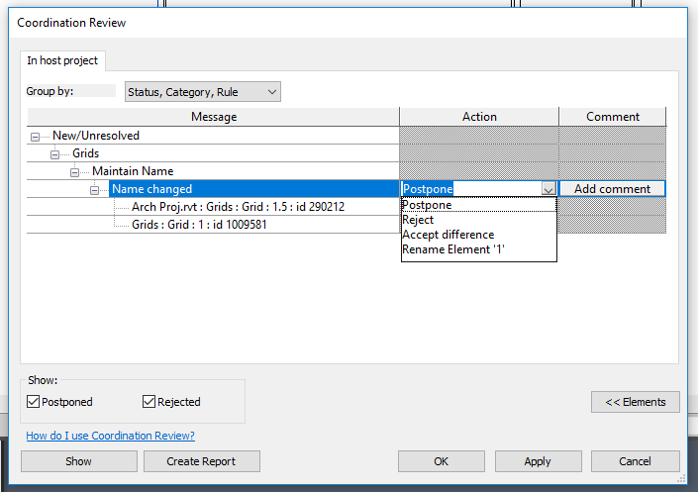To improve design coordination, run the Coordination Review tool to display a list of warnings about monitored grids and levels that have moved or changed. Teams can periodically review this list and specify an action (such as reject the change or modify the design).

Figure 3.5‑1 Coordination Review

* When a copy/monitored element is deleted from the source file, the warning cannot be resolved until the copied element is re-associated with a new object. To fix this, the copied element needs to be re-associated with a new linked family, followed by a break (stop) of the monitoring relationship.

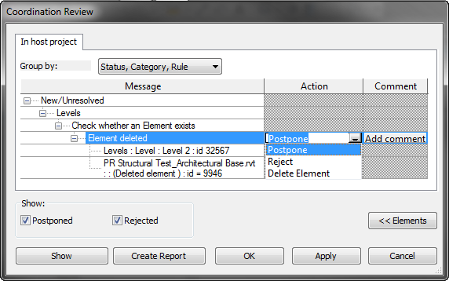

Figure 3.5‑2 Postpone Action